Project 7-1: Shipping Calculator

Objectives
Use concepts from Chapter 7 to complete Project 7-1

Description
Create a program that calculates the total cost of an order including shipping.

Requirements
- Use the following table to calculate shipping cost:
  - If the cost of the item is less than 30.00, shipping is 5.95
  - If the cost of the item is 30.00-49.99, the shipping is 7.95
  - If the cost of the item is 50.00-74.99, the shipping is 9.95
  - If the cost of the item is 75.00 or more, the shipping is FREE
- If the user enters a number that’s less than zero, display an error message and give the user a chance to enter the number again
- The expected output image provides the format for the program output.

Expected Output
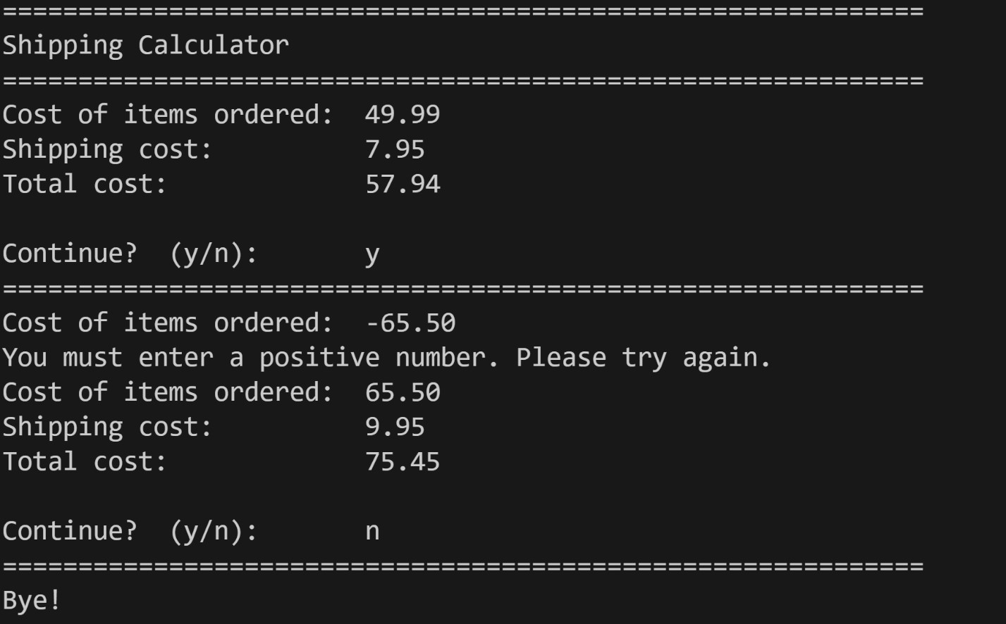

Grading Criteria
File naming convention | 5
Comments (Minimum file header comments and interior code) | 10
Use of input() function | 10
Use of while loop | 15
Correctly handles multiple tries with both positive and negative numbers | 15
User can obtain successive total shipping costs without restarting the program | 15
Program handles all 4 cost ranges | 15
Output format | 15
Code does not compile | -50
Total | 100

